Chat Room with Bootstrap for Front End and Parse or Firebase for Backend

Lab Objectives

1. Learn how to load data dynamically into bootstrap components via jQuery.
2. Learn how to use a backend framework.

Lab Description:

Your goal is to write a multi user chat room with the interface similar to this

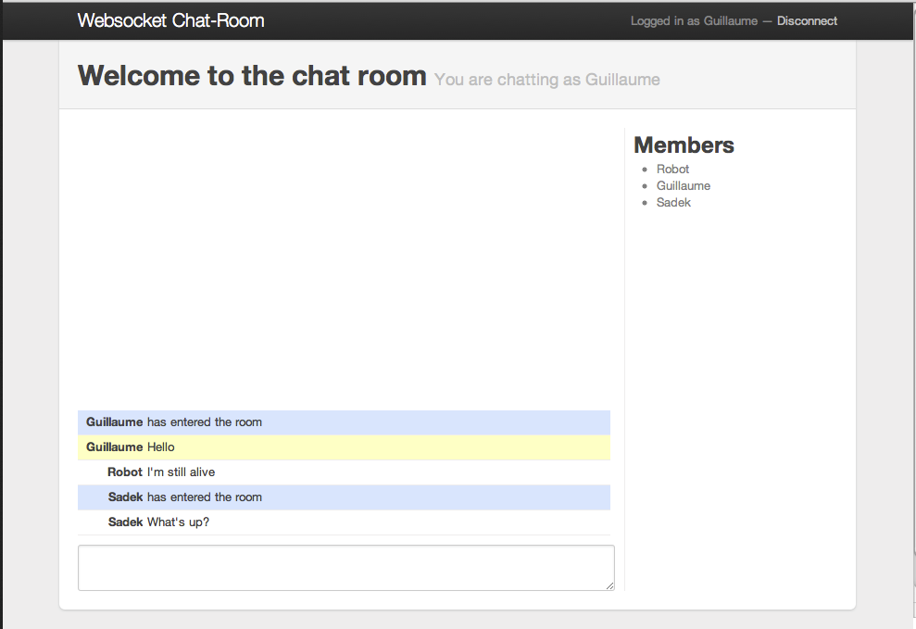

PS: Please ensure that your interface works perfectly on Mobile and Tablet as well.